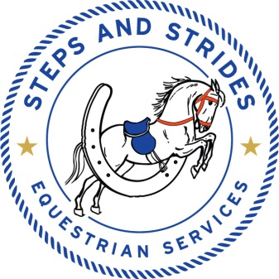3145 High Bridge Rd, Wilmore, KY 40390
Rider Registration and Release Form
Registration
Client Name______________________________________ Gender Male___ Female___
Date of Birth______/_____/____ Age_____
Mailing Address_________________________________________________________
City, State, Zip__________________________________________________________
Phone #___________________________ Work Phone #_______________________
Emergency Phone___________________
Parent Or Guardian’s Name_______________________________________________________
In case of emergency, contact person __________________________phone________________
In case of emergency, contact person __________________________phone________________
Liability Release
________________________(client’s name) would like to participate in Steps and Strides Equestrian Services, Inc. program. I acknowledge the risks and potential for risks of horseback riding. However, I feel the possible benefits to myself/my son/my daughter/my ward are greater than the risk assumed. I hereby, intending to be legally bound, for myself, my heirs and assigns, executors or administrators, waive and release forever all claims and damages against Steps and Strides Equestrian Services, Inc., its Board of Directors, Instructors, Therapists, Aides, Volunteers and/or Employees for any and all injuries and/or losses I/my son/my daughter/my ward may sustain while participating with Steps and Strides Equestrian Services, Inc.
Date_____________________ Signature_________________________________________
Client, Parent or Guardian
Photo Release
I hereby consent to and authorize the use and reproduction by Steps and Strides Equestrian Services, Inc. of any and all photographs and any other audiovisual materials taken of me/my son/my daughter/my ward for promotional printed material, educational activities or any other use for the benefit of the program.
Date___________________________Signature__________________________________
Client, Parent or Guardian

Notice of Privacy Practices
I certify that Steps and Strides Equestrian Services, Inc. gave a copy and explained the Notice of Privacy Practices to me and answered my questions before providing care.
Date__________________________Signature_____________________________________
Client, Parent or Guardian

Rider’s Authorization for Emergency Medical Treatment
In the event emergency medical aid/treatment is required due to illness or injury during the process of receiving services, or while being on the property of the agency, I authorize Steps and Strides Equestrian Services, Inc. to:
- Secure and retain medical treatment and transportation if needed.
- Release client records upon request to the authorized individual or agency involved in the medical emergency treatment.

Client’s Name______________________________________________Phone____________________

Address_______________________________________________________________________

In the event, that I cannot be reached,
Contact _______________________________________phone__________________________
Contact _______________________________________phone__________________________

Physician’s Name_______________________________________________________________

Preferred Medical Facility________________________________________________________

Health Insurance Co _______________________________________Policy #________________

Cont’d

